Financial Performance Dashboard in Tableau

By Biswanandan Hota

# Project Overview

This dashboard analyses the **financial performance** of the company across different countries, products, segments, and time periods.  
It helps stakeholders understand sales, profitability, cost structure, and the impact of discounts on revenue.

# Dataset Summary

The dataset contains the following key fields:  
 **Fields Used:**

* Segment, Country, Product, Discount Band
* Units Sold, Manufacturing Price, Sale Price
* Gross Sales, Discounts, Sales, COGS, Profit
* Date, Month Number, Month Name, Year

**Key Calculations:**

* **Profit Margin:** SUM(Profit) / SUM(Sales)
* **COGS to Sales Ratio:** SUM(COGS) / SUM(Sales)
* **Total Revenue:** SUM(Gross Sales)
* **Discount Impact:** SUM(Discounts) / SUM(Gross Sales)

Visualizations Included

**1️⃣ Sales & Profit by Country (Bar Chart)**

* Displays total sales by country.
* 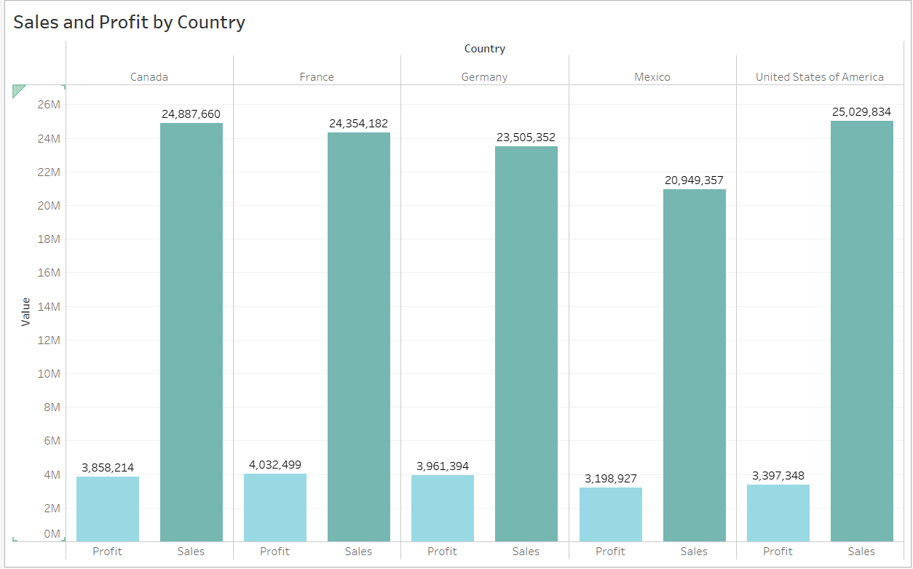Color-coded by total profit to show where profitability is strongest.

**2️⃣ Sales & Profit Trend Over Time (Line Graph)**

* Shows monthly trends in sales and profit across years.
* Split by business segment to highlight trends.

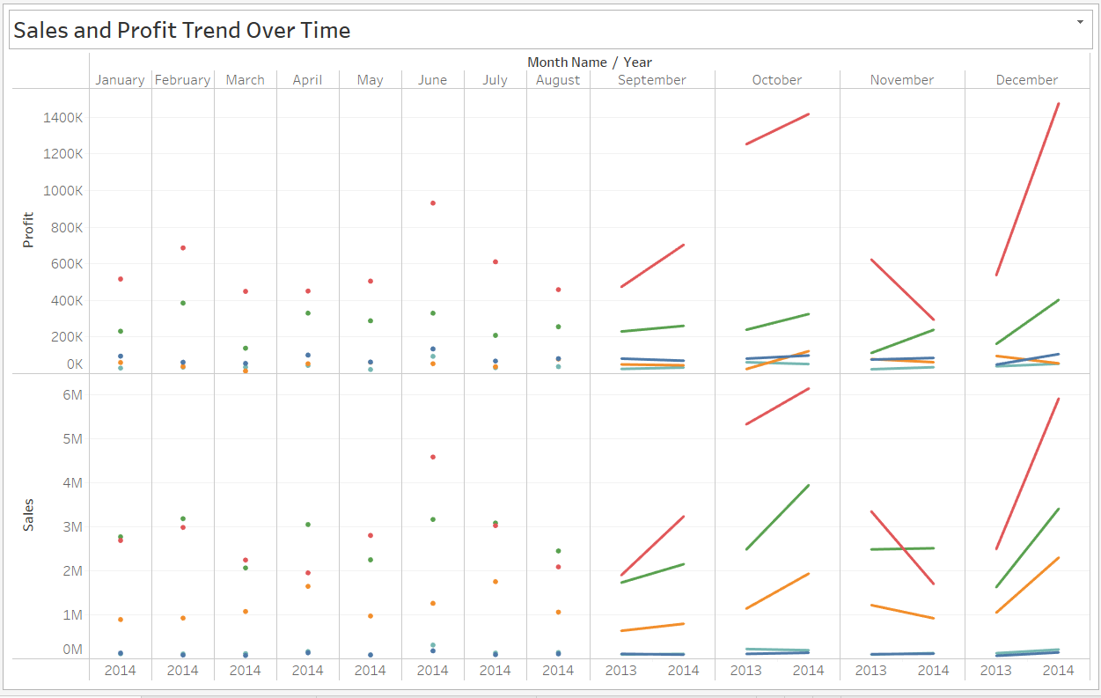

**3️⃣ Gross Sales vs Discounts (Scatter Plot)**

* Illustrates the relationship between gross sales and discounts.
* Highlights how heavy discounts might impact sales volume.

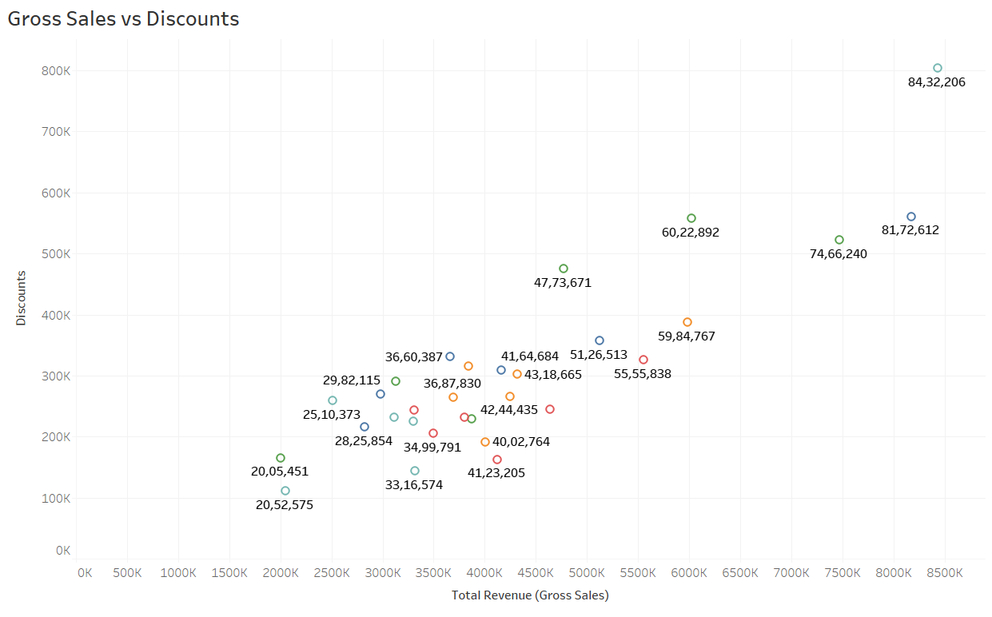

**4️⃣ Sales by Product & Discount Band (Heat Map)**

* Shows how different discount bands impact product sales.
* 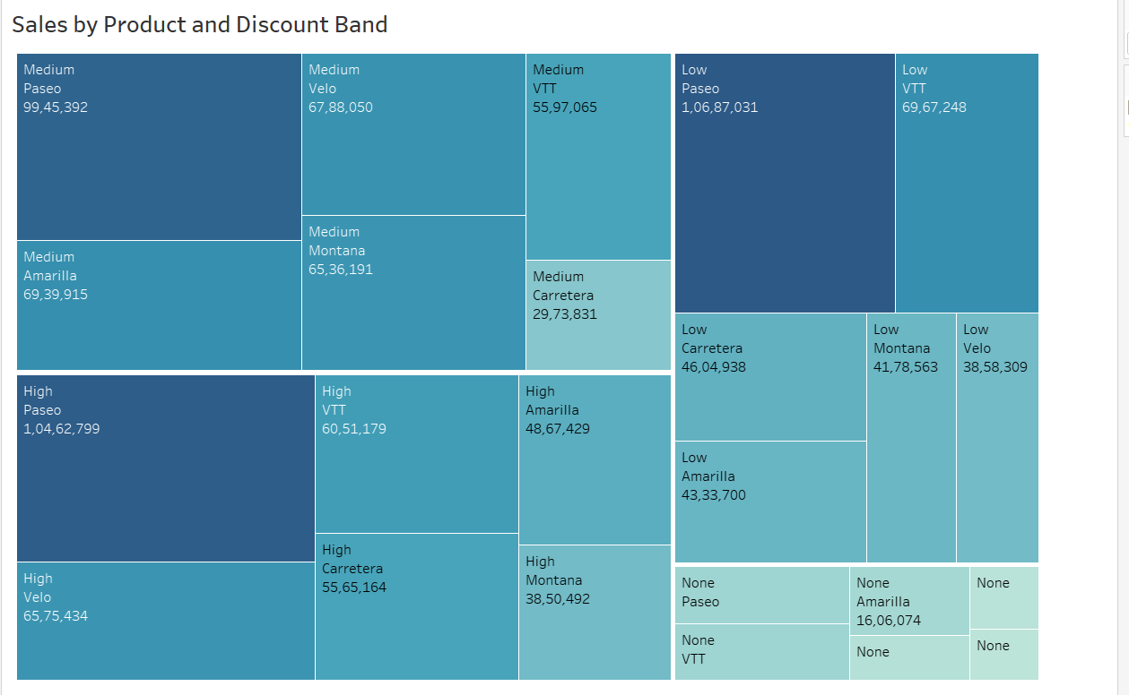Helps identify optimal discount ranges.

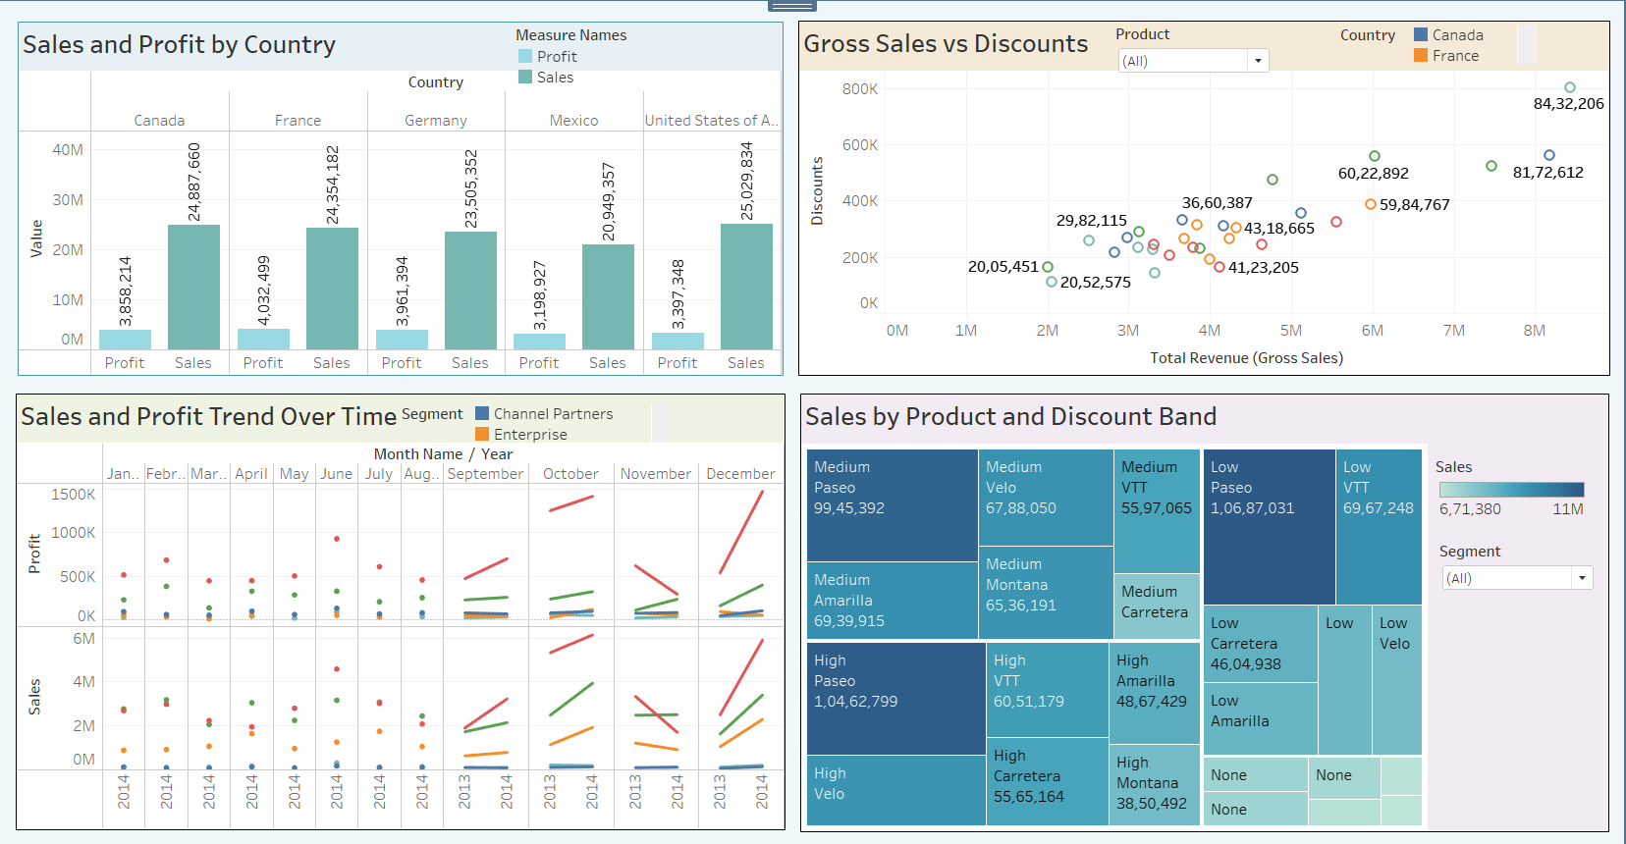Dashboard

**Interactivity & Filters**

* **Segment Filter:** Toggle between Consumer, Corporate, Home Office etc.
* **Country Filter:** Focus analysis on selected countries.

**Outcome & Benefits**

This dashboard provides a comprehensive view of:

* **Revenue & Profitability:** Across products, countries, segments.
* **Discount Strategies:** Helps fine-tune discount bands for maximizing profit.
* **Trends Over Time:** Identifies seasonal or yearly performance patterns.

It serves as a **decision support tool for financial and sales strategy**, enabling data-driven decisions.